Development of a Low-Cost Winch-Controlled Probe to Generate Temperature Profiles of Aquatic Environments

Z. Wu1* & T.I. van Niekerk2*

Department of Mechatronics, Nelson Mandela University, South Africa, s221403116@mandela.ac.za

2 Department of Mechatronics, Nelson Mandela University, South Africa, theo.vanniekerk@mandela.ac.za

**ABSTRACT**

Oceans and lakes represent aquatic habitats harbouring numerous scientific mysteries and crucial ecological data. Temperature profiles within these water bodies play fundamental roles in understanding their dynamic nature and environmental changes. This research focuses on the development of a winch-controlled temperature probe system integrated on an autonomous boat, with sensors, microcontrollers, safety mechanisms and navigation. Testing showcased the system's capability to acquire temperature profiles in relatively shallow waters while compensating for heaving motions. The results obtained from the experiments confirm overall system development, highlighting the dynamic thermal distribution within the lake environment and understanding the underlying factors driving these fluctuations.

___________________________________

*Corresponding author

**INTRODUCTION**

Temperature fluctuations, particularly with different depths, significantly impact the freshwater and marine ecosystems, climate patterns, and provide comprehensive environmental insights [1]. Current research tools like the Conductivity, Temperature, and Depth (CTD) probe [2] and satellite Sea Surface Temperature (SST) mapping [3], have yielded precise oceanic temperature profiles. However, these tools are either costly or impractical for shallow water deployment. This study focuses on leveraging cost-effective components to enhance marine temperature profiling in relatively shallow waters, addressing challenges such as heave adjustment [4], GPS navigation, data communication [5], waterproofing, as well as the temperature measurement. This study aims to offer a cost-effective solution while elevating the comprehension of marine temperature profiles to expand research opportunities in aquatic environments.

**Methodology and results**

The overall system layout is shown in Figure 1, and it utilizes a single on-board microcontroller to manage various tasks during data collection. This includes logging the boat's GPS coordinates 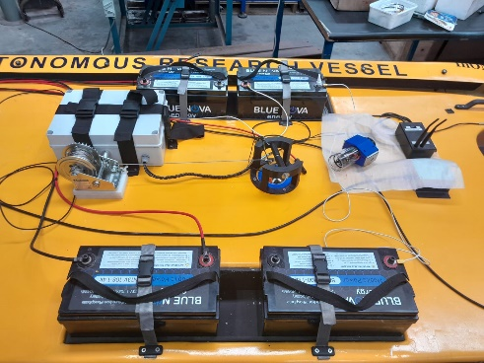and data collection timestamps, as well as handling Inertial Measurement Unit (IMU) data to stabilize winch operations and mitigate heaving motion [2]. Additionally, it supervises safety relays and limit switches to ensure operational safety. Another microcontroller, situated within the probe deployed into the water via winching, records temperature, pressure, and Real-Time Clock (RTC) data onto a separate SD card. The winch system, integrated onto the autonomous boat and connected to the probe via stainless steel cables, guarantees robust data collection across diverse water environments [5]. During retrieval, both microcontrollers synchronize data using fixed RTC timestamps, facilitating subsequent graph plotting [6, 7].

**Figure 1: Overall System Layout**

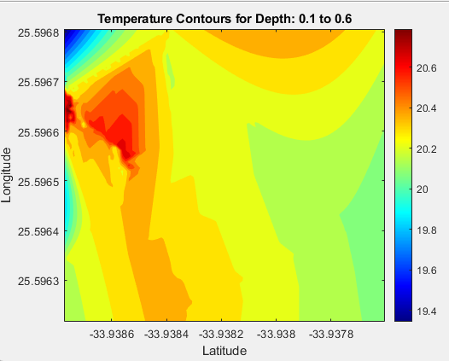Figure 2 depicts the contour plots generated for depths ranging from 0.1 to 0.6 meters using MATLAB. These plots illustrate the integration of GPS and temperature data obtained from experiments conducted at a lake in Gqeberha, South Africa. With contour plots and depth layer segmentation, the data reveal significant temperature variations across various depths and locations within the lake. These results highlight the efficacy of the system's technical development and the feasibility to acquire data using cost-effective components. Overall, the findings indicate decreasing temperatures with depth and variations between the lake's centre and its shorelines [8].

**Figure 2: Contour of Depth Layer 1**

**CONCLUSION**

In conclusion, the developed temperature profiling system represents an advancement in low-cost aquatic research instrumentation. Through the integration of microcontrollers, promising data collection of GPS coordinates, IMU data for appropriate heaving compensation, and environmental findings is achieved. Future directions should explore deeper waters and diverse locations in the lake or oceanic environments. These acquired testing results provide a proof of concept for the system in action, as well as a basis for understanding temperature profiles' implications on aquatic research.

**REFERENCES**

1. **Antão, L.H., Bates, A.E. & Blowes, S.A.** 2020. Temperature-related biodiversity change across temperate marine and terrestrial systems. *Nature Ecology & Evolution*, 4(7), pp. 927–933. doi:https://doi.org/10.1038/s41559-020-1185-7.
2. **Carral, L., de Lara Rey, J., Alvarez-Feal, J.C. & Carral Couce, J.** 2017. Winch control gear for CTD sampling with a system to compensate vertical motion heave when manoeuvring in rough seas. *Ocean Engineering*, 135, pp. 246–257. doi:https://doi.org/10.1016/j.oceaneng.2017.03.005.
3. **Jaelani, L.M. & Alfatinah, A.** 2017. Sea Surface Temperature Mapping at Medium Scale Using Landsat 8 -TIRS Satellite Image. *IPTEK Journal of Proceedings Series*, 3(6). doi:https://doi.org/10.12962/j23546026.y2017i6.3307.
4. **Woodacre, J.K., Bauer, R.J. & Irani, R.A.** 2015. A review of vertical motion heave compensation systems. *Ocean Engineering*, 104, pp. 140–154. doi:https://doi.org/10.1016/j.oceaneng.2015.05.004.
5. **Duraibabu, D.B., Leen, G., Toal, D., Newe, T., Lewis, E. & Dooly, G.** 2017. Underwater Depth and Temperature Sensing Based on Fiber Optic Technology for Marine and Fresh Water Applications. *Sensors*, [online] 17(6), p.1228. doi:https://doi.org/10.3390/s17061228.
6. **Sanchana, S., A.P., M. & Jyothi, B.N.** 2021. Application Development for Real-Time Location Tracking for Underwater Vehicles Using Low-Cost GPS with GSM. *2021 Sixth International Conference on Wireless Communications, Signal Processing and Networking (WiSPNET)*. doi:https://doi.org/10.1109/wispnet51692.2021.9419421.
7. **Silva Junior, A., Lima Sa, S., Santos, D., Negreiros, Á., Souza Silva, J., Álvarez Jácobo, J. & Garcia Gonçalves, L.** 2016. Towards a Real-Time Embedded System for Water Monitoring Installed in a Robotic Sailboat. *Sensors*, 16(8), p.1226. doi:https://doi.org/10.3390/s16081226.
8. **www.greenseaupwelling.com.** n.d. *Natural Upwelling*. [online] Available at: http://www.greenseaupwelling.com/Upwelling.html.
9. **Wikipedia.** 2020. *Sea surface temperature*. [online] Available at: https://en.wikipedia.org/wiki/Sea_surface_temperature.